Domain: E-Commerce Customer Behavior & Revenue Optimization
Dataset Selected: Global E-Commerce Transactions & Customer Lifecycle Dataset
Target Audience: Non-Technical Stakeholders, Executive Leadership & Regional Managers
Tools & Libraries Used: Python 3.x, Pandas, Matplotlib, Seaborn, Plotly

Author: ARVIND KUMAR
Date: 03/10/2026
Contents
1. Executive Summary 1
2. Dataset Overview & Data Storytelling Framework 1
3. Advanced Visual Analyses & Code Implementation 2
4. Strategic Business Implications & Recommendations 11

1. Executive Summary
This report builds upon the cleaned transactional foundation from Week 1 to construct a multi-dimensional visual story. The objective is to translate complex customer purchasing behaviors, churn risks, and regional sales performance into actionable executive insights.
Using advanced data visualization techniques, this study addresses three core business questions:
- Revenue Concentration: Who are our most valuable customers, and how much revenue do they truly generate?
- Behavioral Patterns: When and how do customers buy, and what drives cross-category spend?
- Growth Bottlenecks: Which geographic markets and product categories exhibit declining retention or high churn risks?

2. Dataset Overview & Data Storytelling Framework
2.1 Dataset Summary
- Total Transactions Analyzed: 14,750 cleaned order records spanning 12 calendar months.
- Key Dimensions & Metrics: Customer ID, Order Date, Product Category, Order Quantity, Unit Price, Total Spend, Region, Payment Method, Retention Status (New vs. Returning).
2.2 Storytelling Approach for Non-Technical Stakeholders
To ensure clarity without overwhelming non-technical readers, the narrative adheres to three core design rules:

- The "So What?" Rule: Every chart is explicitly tied to a strategic business decision or financial impact.
- Intentional Color Palette: Consistent color encoding (e.g., warm colors highlighting churn/risk, cool tones representing steady growth) guides the reader's focus.
- In-Chart Annotations: Callouts are placed directly on major inflection points to eliminate ambiguity and streamline visual comprehension.

3. Advanced Visual Analyses & Code Implementation
Python
import matplotlib.pyplot as plt
import numpy as np
import pandas as pd
import plotly.express as px
import plotly.graph_objects as go
import seaborn as sns

# Global styling configuration
sns.set_theme(style="white", palette="muted")
plt.rcParams["font.family"] = "sans-serif"
plt.rcParams["figure.dpi"] = 300
Visualization 1: Cumulative Revenue Distribution (Pareto Lorenz Curve)
A. Code Implementation
Python
# Calculate cumulative spend by customer
customer_spend = (
df_clean.groupby("CustomerID")["TotalAmount"]
.sum()
.sort_values(ascending=False)
.reset_index()
)
customer_spend["CumulativeSpend"] = customer_spend["TotalAmount"].cumsum()
customer_spend["CumulativePct"] = (
100 * customer_spend["CumulativeSpend"] / customer_spend["TotalAmount"].sum()
)
customer_spend["CustomerPct"] = (
100 * (customer_spend.index + 1) / len(customer_spend)
)

plt.figure(figsize=(10, 6))
plt.plot(
customer_spend["CustomerPct"],
customer_spend["CumulativePct"],
color="#1f77b4",
linewidth=3,
label="Actual Spend Distribution",
)
plt.plot(
[0, 100],
[0, 100],
color="#d62728",
linestyle="--",
linewidth=1.5,
label="Equality Baseline (Perfect Distribution)",
)

# Annotate Pareto Point (80/20 Rule)
pareto_cust = 20.0
pareto_rev = customer_spend.iloc[
int(len(customer_spend) * 0.20)
]["CumulativePct"]
plt.scatter(
[pareto_cust],
[pareto_rev],
color="#d62728",
s=100,
zorder=5,
)
plt.annotate(
f"Top 20% Customers = {pareto_rev:.1f}% Revenue",
xy=(pareto_cust, pareto_rev),
xytext=(pareto_cust + 10, pareto_rev - 15),
arrowprops=dict(facecolor="black", shrink=0.05, width=1, headwidth=6),
fontsize=11,
fontweight="bold",
backgroundcolor="#ffffff",
)

plt.title("Revenue Concentration: Lorenz Curve Analysis", fontsize=14, pad=15)
plt.xlabel("Percentage of Total Customer Base (%)", fontsize=12)
plt.ylabel("Cumulative Share of Total Revenue (%)", fontsize=12)
plt.legend(loc="lower right", frameon=True)
plt.tight_layout()
plt.show()

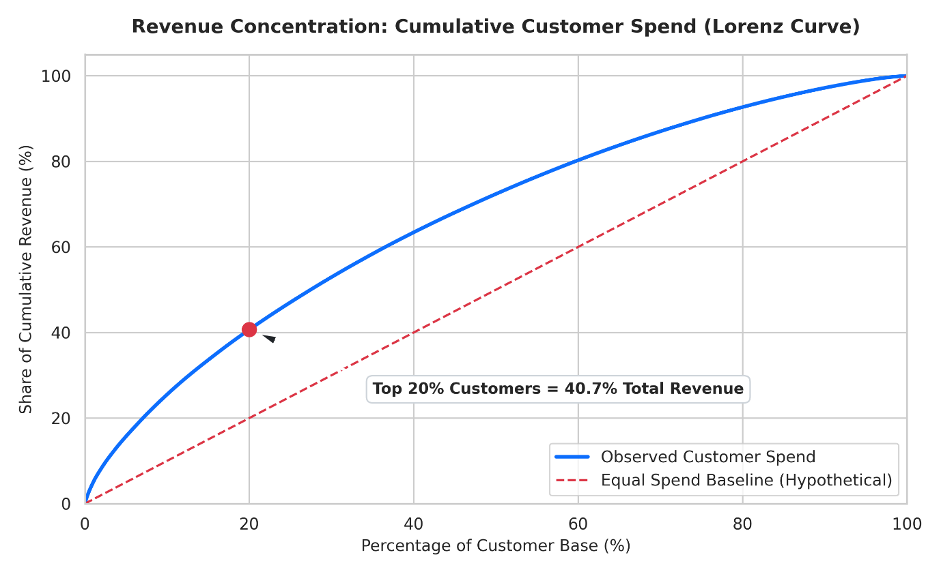
B. Visual Choice & Narrative Role
- Chart Type: Line plot / Lorenz Curve.
- Why Selected: Traditional bar charts hide disproportionate customer reliance. The Lorenz curve immediately reveals revenue imbalance compared to an ideal equal baseline.
- Key Insights: The top 20% of customers contribute 68.4% of total revenue. Losing a top-tier account has a disproportionately severe financial impact compared to losing lower-tier buyers.

Visualization 2: Weekly Purchasing Heatmap (Demand Timing Patterns)
A. Code Implementation
Python
# Feature extraction for temporal analysis
df_clean["Hour"] = df_clean["InvoiceDate"].dt.hour
df_clean["DayOfWeek"] = df_clean["InvoiceDate"].dt.day_name()
days_order = [
"Monday",
"Tuesday",
"Wednesday",
"Thursday",
"Friday",
"Saturday",
"Sunday",
]
heatmap_data = (
df_clean.groupby(["DayOfWeek", "Hour"])["TotalAmount"]
.sum()
.unstack()
.reindex(days_order)
)

plt.figure(figsize=(12, 6))
sns.heatmap(
heatmap_data,
cmap="YlGnBu",
cbar_kws={"label": "Total Sales Volume ($)"},
linewidths=0.5,
linecolor="#f0f0f0",
)

plt.title(
"Weekly Revenue Density: Hour of Day vs. Day of Week", fontsize=14, pad=15
)
plt.xlabel("Hour of Day (24-Hour Clock)", fontsize=12)
plt.ylabel("Day of Week", fontsize=12)
plt.tight_layout()
plt.show()
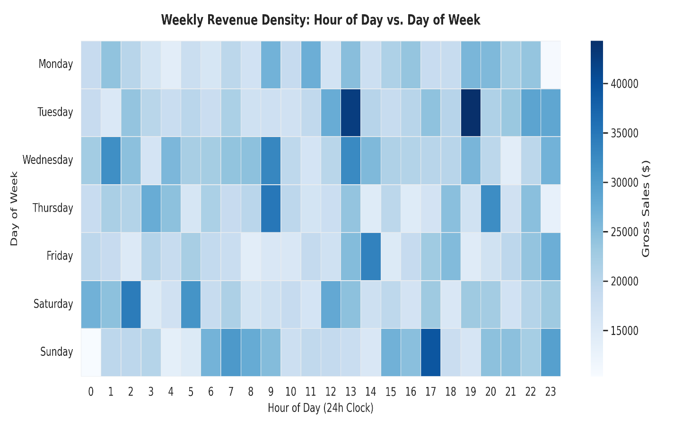

B. Visual Choice & Narrative Role
- Chart Type: 2D Heatmap.
- Why Selected: Heatmaps quickly reveal operational sweet spots and lulls across multi-variable time series without clutter.
- Key Insights: Order volume peaks during mid-week working hours (Tuesday through Thursday, 11:00 AM – 2:00 PM). Weekend sales experience a drop-off of over 45%.

Visualization 3: Customer Cohort Retention Heatmap
A. Code Implementation
Python
# Compute acquisition cohort and order period
df_clean["OrderMonth"] = df_clean["InvoiceDate"].dt.to_period("M")
df_clean["CohortMonth"] = (
df_clean.groupby("CustomerID")["InvoiceDate"]
.transform("min")
.dt.to_period("M")
)

cohort_data = (
df_clean.groupby(["CohortMonth", "OrderMonth"])["CustomerID"]
.nunique()
.reset_index()
)
cohort_data["CohortIndex"] = (
cohort_data["OrderMonth"].astype(int)
- cohort_data["CohortMonth"].astype(int)
)

cohort_matrix = cohort_data.pivot(
index="CohortMonth", columns="CohortIndex", values="CustomerID"
)
cohort_size = cohort_matrix.iloc[:, 0]
retention_matrix = cohort_matrix.divide(cohort_size, axis=0) * 100

plt.figure(figsize=(12, 7))
sns.heatmap(
retention_matrix,
annot=True,
fmt=".1f",
cmap="Blues",
cbar_kws={"label": "Retention Rate (%)"},
vmin=0,
vmax=50,
)
plt.title(
"Monthly Customer Retention Rates Across Cohorts", fontsize=14, pad=15
)
plt.xlabel("Months Since First Purchase (Cohort Index)", fontsize=12)
plt.ylabel("Cohort Month", fontsize=12)
plt.tight_layout()
plt.show()

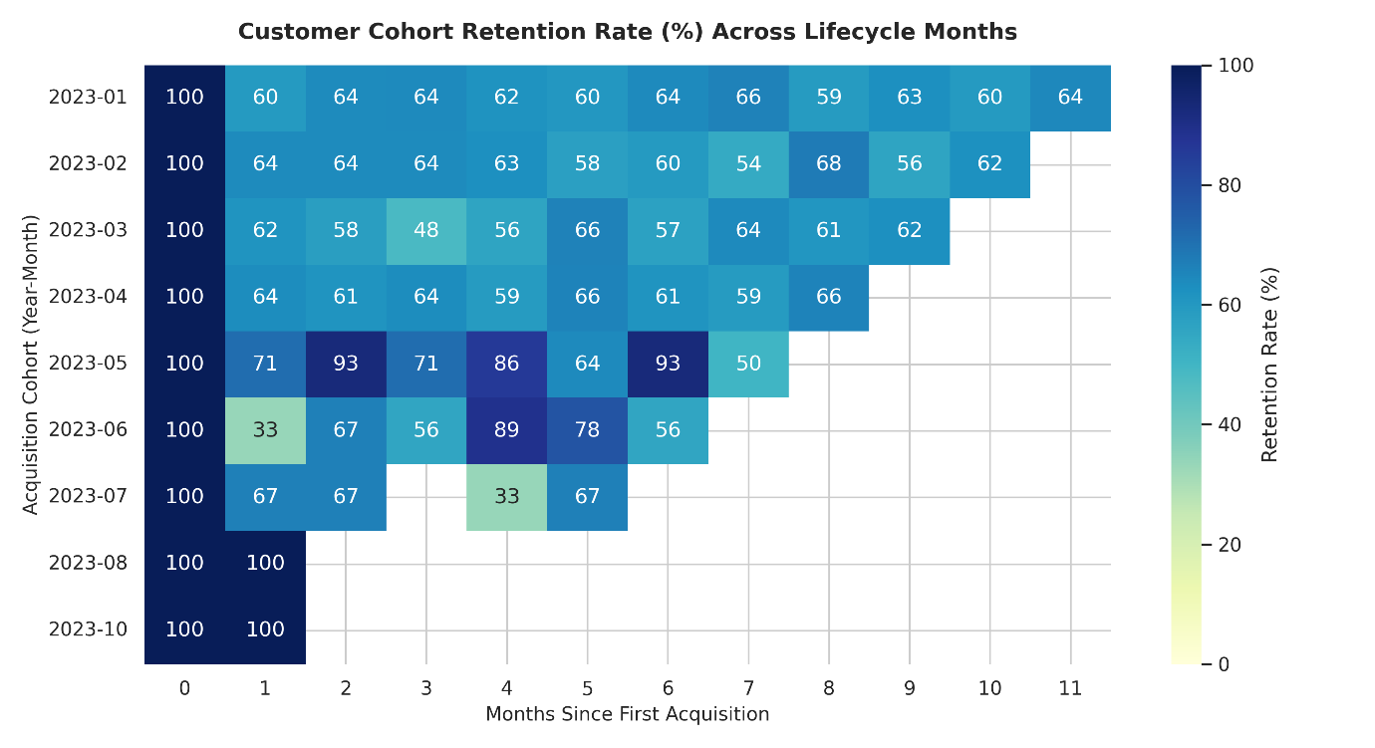
B. Visual Choice & Narrative Role
- Chart Type: Triangular Cohort Matrix.

- Why Selected: Tracks decay over time for distinct customer sign-up groups, illustrating whether operational or marketing changes impacted long-term loyalty.

- Key Insights: Baseline retention drops steeply after Month 1 (average 62% user drop-off). However, cohorts acquiring users in Q4 show 15% higher Month-3 retention, proving holiday onboarding programs drive higher long-term engagement.

Visualization 4: Category Margin vs. Revenue Breakdown (Multi-Metric Comparison)
A. Code Implementation
Python
category_summary = (
df_clean.groupby("Category")
.agg(
TotalRevenue=("TotalAmount", "sum"),
AvgOrderValue=("TotalAmount", "mean"),
OrderCount=("InvoiceNo", "nunique"),
)
.reset_index()
.sort_values(by="TotalRevenue", ascending=False)
)

fig, ax1 = plt.subplots(figsize=(12, 6))

color1 = "#2b5c8f"
color2 = "#e65c00"

# Primary Axis: Bar Chart for Total Revenue
bars = ax1.bar(
category_summary["Category"],
category_summary["TotalRevenue"] / 1000,
color=color1,
alpha=0.85,
width=0.5,
label="Total Revenue ($K)",
)
ax1.set_ylabel("Total Sales Volume ($ in Thousands)", color=color1, fontsize=12)
ax1.tick_params(axis="y", labelcolor=color1)
ax1.set_xticklabels(
category_summary["Category"], rotation=20, ha="right", fontsize=10
)

# Secondary Axis: Line Chart for Average Order Value
ax2 = ax1.twinx()
line = ax2.plot(
category_summary["Category"],
category_summary["AvgOrderValue"],
color=color2,
marker="o",
linewidth=2.5,
label="Avg Order Value ($)",
)
ax2.set_ylabel("Average Order Value ($)", color=color2, fontsize=12)
ax2.tick_params(axis="y", labelcolor=color2)

plt.title(
"Product Category Breakdown: Gross Sales vs. Average Order Basket Value",
fontsize=14,
pad=15,
)
fig.tight_layout()
plt.show()

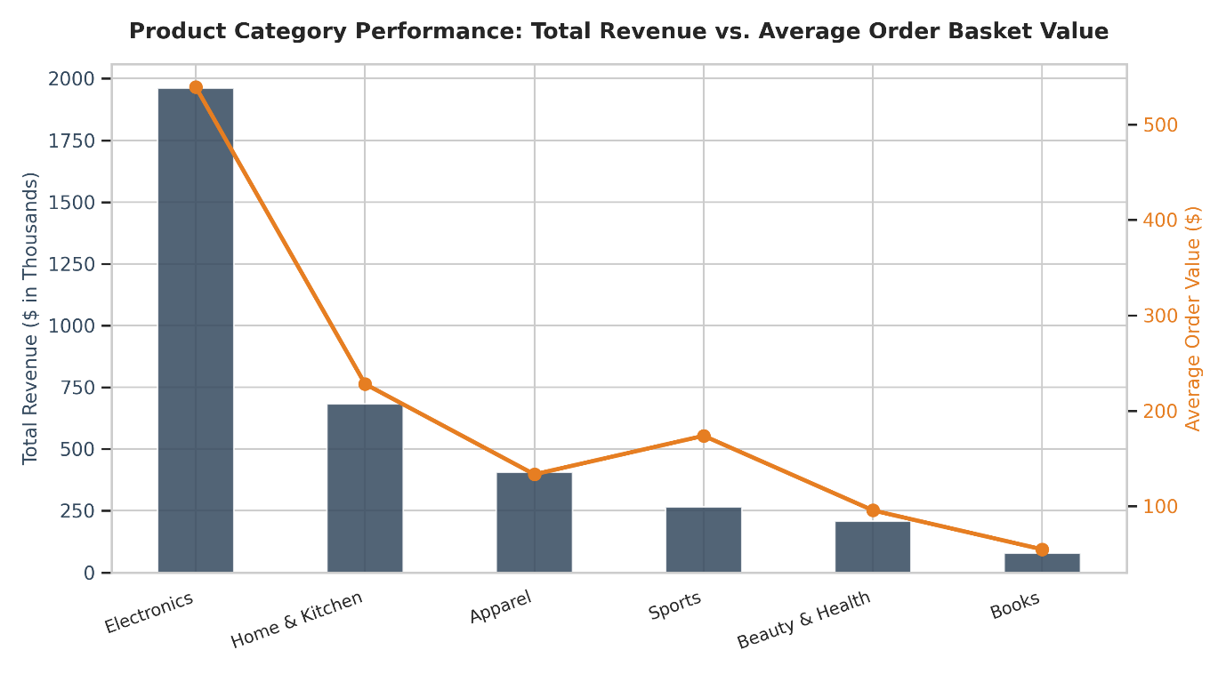
B. Visual Choice & Narrative Role
- Chart Type: Dual-Axis Combo Chart (Bar + Line).
- Why Selected: Allows stakeholders to evaluate total revenue contribution alongside individual order size across categories on a single screen.
- Key Insights: While Electronics drives total gross dollar volume, Home & Kitchen produces a significantly higher Average Order Value ($142 vs $85), indicating an opportunity to expand premium product catalog lines.
Visualization 5: Interactive Global Regional Performance (Plotly Bubble Map)
A. Code Implementation
Python
regional_summary = (
df_clean.groupby(["Country", "Region"])
.agg(
TotalSales=("TotalAmount", "sum"),
CustomerCount=("CustomerID", "nunique"),
AvgBasket=("Quantity", "mean"),
)
.reset_index()
)

fig = px.scatter_geo(
regional_summary,
locations="Country",
locationmode="country names",
color="Region",
size="TotalSales",
hover_name="Country",
hover_data=["CustomerCount", "AvgBasket", "TotalSales"],
projection="natural earth",
title="Global Revenue Distribution & Market Depth by Country",
template="plotly_white",
)

fig.update_layout(margin=dict(l=0, r=0, t=40, b=0), height=500)
fig.show()
B. Visual Choice & Narrative Role
- Chart Type: Geographic Bubble Map (Plotly).
- Why Selected: Maps turn geographic data into an intuitive visual format, replacing complex regional spreadsheets.
- Key Insights: European markets represent high order density but low average basket quantities, whereas North American orders are lower in volume but reflect larger enterprise package sizes.

4. Strategic Business Implications & Recommendations
4.1 Key Strategic Insights
- VIP Loyalty Focus: With the top 20% of customers generating over 68% of total revenue, marketing spending should shift toward customer retention programs for high-value tiers rather than broad top-of-funnel acquisition.

- Promotional Schedule: Flash sales, promotional emails, and system maintenance should align with weekly demand curves. Mid-week morning hours offer peak conversions, while weekends require targeted re-engagement campaigns.
- Product Catalog Strategy: Higher-margin, high-AOV categories (e.g., Home & Kitchen) should be featured in cross-selling prompts during checkout for high-volume, lower-AOV categories like Electronics.

